**Cardiovascular Health Analysis**

Name:

Abhishekk S Pathak

Date:

20/04/2024

Special Thanks To:   
Hemani Gupta

Surya Singh

**INDEX**

Project Background

Importance of Predicting Analysis of Heart Diseases

Objectives and Goals of the Analysis

Summary Of The Provided Data

Variables and Their Significance

Challenges / Error Faced

Data Cleaning: Detailed Steps

Exploratory Data Analysis (EDA)

Feature Engineering and Data Processing

Model Selection

Explanation of the Models Used

Reasons for Selecting Model

Power BI Dashboard Overview

**Project Background:**

The project aims to utilize predictive analytics to address the critical issue of heart disease, a leading cause of mortality worldwide. By leveraging machine learning algorithms, the goal is to develop a predictive model capable of early detection and risk assessment of heart diseases based on patient data. This project is driven by the pressing need to enhance healthcare outcomes, reduce healthcare costs, and improve patient care through proactive measures. Through comprehensive analysis and model development, the project seeks to empower healthcare professionals with actionable insights for timely intervention and improved patient management.

**Importance of Predicting Analysis of Heart Diseases**

Predicting heart diseases is crucial for resource optimization in healthcare facilities. By identifying individuals at high risk of developing heart diseases, healthcare providers can allocate resources more efficiently, ensuring that diagnostic tests, treatments, and interventions are prioritized for those who need them most. This helps to minimize unnecessary healthcare expenditures while maximizing the impact of available resources.

Financial management in healthcare is significantly enhanced through predictive analytics for heart diseases. By implementing early detection and risk assessment strategies, healthcare organizations can reduce the financial burden associated with treating advanced stages of heart diseases. Moreover, preventive measures and lifestyle interventions driven by predictive models can lead to long-term cost savings by preventing costly hospitalizations and medical procedures.

Predictive analytics for heart diseases plays a pivotal role in patient care planning. Healthcare providers can proactively identify individuals at risk and tailor personalized care plans to mitigate their risk factors and prevent the onset or progression of heart diseases. This empowers patients to take control of their health through targeted interventions such as lifestyle modifications, medication adherence, and regular monitoring, leading to improved health outcomes and quality of life. Additionally, predictive models facilitate shared decision-making between healthcare providers and patients, fostering a collaborative approach to managing heart diseases and promoting patient engagement in their care journey.

**Objectives and Goals of the Analysis:**

**Predicting the Likelihood of Heart Diseases:**

The primary objective of the analysis is to develop predictive models capable of accurately predicting the likelihood of heart diseases based on patient data. By leveraging machine learning algorithms, the analysis aims to identify patterns and relationships within the data that can help forecast the risk of developing heart diseases in individuals.

**Identifying Significant Factors Associated with Heart Diseases:**

Another key goal of the analysis is to identify the significant factors or variables that are strongly associated with heart diseases. Through comprehensive data exploration and statistical analysis, the analysis seeks to uncover the key determinants of heart diseases, including demographic, clinical, and lifestyle factors.

**Developing a Predictive Model for Early Detection:**

The analysis aims to develop a predictive model that can facilitate early detection of heart diseases. By leveraging advanced machine learning techniques, the model will be trained on historical patient data to predict the likelihood of heart diseases in new patients. The ultimate goal is to provide healthcare professionals with a reliable tool for early risk assessment and intervention, leading to improved patient outcomes and reduced healthcare costs.

These objectives and goals guide the analysis process and serve as the foundation for the development of predictive models aimed at enhancing the early detection and management of heart diseases.

**Summary Of The Provided Data**

**Data Source and Collection Methods:**

The dataset used in the analysis was sourced from [insert data source]. The collection methods involved [describe data collection methods, such as surveys, clinical records, etc.]. The dataset represents a compilation of [describe the population or sample from which the data was collected, such as patients with suspected heart diseases, general population, etc.].

**Number of Records and Attributes:**

The dataset consists of [insert number of records] records or observations and [insert number of attributes] attributes or variables. Each record represents [describe what each record or observation represents, such as an individual patient, a medical encounter, etc.]. The attributes capture various characteristics or measurements associated with [describe the scope or focus of the dataset, such as patient demographics, clinical parameters, etc.].

**Description of Key Variables:**

The dataset contains a variety of key variables that are relevant to the analysis of heart diseases. These variables include:

[List key variables and their descriptions, such as age, sex, and chest pain type, resting blood pressure, serum cholesterol, etc.]. Each variable provides important insights into [describe what aspect of heart diseases or related factors each variable represents, such as risk factors, clinical indicators, etc.].

This summary provides an overview of the dataset used in the analysis, including its source, composition, and key variables. It serves as the foundation for further exploration and analysis of the data to achieve the objectives of the project.

**Variables** **And Their Significance**

**Key Variables:**

**Age:** Age is a critical variable in predicting heart diseases as it is strongly associated with cardiovascular health. Older individuals are generally at a higher risk of developing heart diseases due to the natural aging process, increased exposure to risk factors, and cumulative effects of lifestyle choices. Age serves as an important predictor of heart diseases, with advancing age being positively correlated with the likelihood of developing cardiovascular conditions.

**Sex:** Gender (male/female) is another significant variable in predicting heart diseases. Research has shown that men tend to have a higher risk of heart diseases compared to women, particularly at younger ages. Sex differences in cardiovascular physiology, hormone levels, and lifestyle behaviors contribute to variations in heart disease risk between males and females. Therefore, sex serves as an important demographic variable in predictive models for heart diseases.

**Chest Pain Type (CP):** Chest pain type is a clinical variable that provides valuable information about the nature and severity of cardiovascular symptoms. Different types of chest pain, such as typical angina, atypical angina, non-typical angina, and asymptomatic chest pain, may indicate varying degrees of coronary artery disease or other cardiac conditions. Therefore, chest pain type serves as a significant predictor of heart diseases, with certain types of chest pain being strongly associated with an increased risk of cardiovascular events.

**Resting Blood Pressure (trestbps):** Resting blood pressure is a crucial physiological variable that reflects the force exerted by blood against the walls of the arteries when the body is at rest. Elevated blood pressure, or hypertension, is a well-established risk factor for heart diseases, including coronary artery disease, heart failure, and stroke. Therefore, resting blood pressure serves as an important clinical parameter in predicting the likelihood of developing heart diseases, with higher blood pressure levels indicating a greater risk of cardiovascular complications.

**Serum Cholesterol (chol):** Serum cholesterol levels, specifically low-density lipoprotein cholesterol (LDL-C) and high-density lipoprotein cholesterol (HDL-C), are key lipid markers that play a significant role in cardiovascular health. Elevated LDL-C levels and reduced HDL-C levels are associated with an increased risk of atherosclerosis, coronary artery disease, and myocardial infarction. Therefore, serum cholesterol serves as a critical biomarker in predictive models for heart diseases, with abnormal lipid profiles indicating an elevated risk of cardiovascular events.

**Fasting Blood Sugar (fbs):** Fasting blood sugar levels provide insights into glucose metabolism and insulin sensitivity, both of which are closely linked to cardiovascular health. Elevated fasting blood sugar levels, indicative of impaired glucose tolerance or diabetes mellitus, are associated with an increased risk of heart diseases, including coronary artery disease, peripheral vascular disease, and heart failure. Therefore, fasting blood sugar serves as an important metabolic variable in predicting the likelihood of developing heart diseases, with higher blood sugar levels indicating a greater risk of cardiovascular complications.

**Resting Electrocardiographic Results (restecg):** Resting electrocardiographic results provide information about the electrical activity of the heart at rest, including the presence of abnormal heart rhythms, conduction abnormalities, and ischemic changes. Abnormal resting electrocardiographic findings, such as ST-segment abnormalities, T-wave inversions, and arrhythmias, may indicate underlying cardiac pathology or increased cardiovascular risk. Therefore, resting electrocardiographic results serve as valuable diagnostic and prognostic indicators in predictive models for heart diseases, with abnormal findings suggesting an elevated risk of cardiovascular events.

**Maximum Heart Rate Achieved (thalach)**: Maximum heart rate achieved during exercise testing is an important physiological variable that reflects cardiac performance and exercise capacity. Reduced maximum heart rate, indicative of impaired cardiac function or exercise intolerance, is associated with an increased risk of heart diseases, including coronary artery disease and heart failure. Therefore, maximum heart rate achieved serves as a significant predictor of cardiovascular health, with lower heart rate values indicating a higher risk of cardiovascular complications.

**Exercise Induced Angina (exang):** Exercise-induced angina refers to chest pain or discomfort experienced during physical exertion, typically due to inadequate blood flow to the heart muscle. The presence of exercise-induced angina is a strong indicator of underlying coronary artery disease and ischemic heart disease. Therefore, exercise-induced angina serves as a critical clinical symptom in predictive models for heart diseases, with its presence indicating a heightened risk of cardiovascular events.

**ST Depression Induced by Exercise Relative to Rest (oldpeak):** ST depression induced by exercise relative to rest is an electrocardiographic finding that reflects myocardial ischemia or reduced blood flow to the heart muscle during physical exertion. Greater ST depression values are indicative of more severe ischemia and a higher likelihood of significant coronary artery disease. Therefore, ST depression serves as a valuable diagnostic parameter in predictive models for heart diseases, with higher ST depression values suggesting an increased risk of cardiovascular complications.

**Slope of the Peak Exercise ST Segment (slope):** The slope of the peak exercise ST segment is an electrocardiographic parameter that describes the pattern of ST segment changes during exercise testing. The slope may be upsloping, flat, or downsloping, with different slope patterns indicating varying degrees of myocardial ischemia or coronary artery disease. Therefore, the slope of the peak exercise ST segment serves as an important diagnostic indicator in predictive models for heart diseases, with certain slope patterns being associated with an elevated risk of cardiovascular events.

**Number of Major Vessels Colored by Flourosopy (ca**): The number of major vessels colored by fluoroscopy represents the extent of coronary artery disease or atherosclerotic plaque burden in the coronary arteries. A higher number of major vessels with significant stenosis or occlusion is indicative of more advanced coronary artery disease and a greater risk of cardiovascular events. Therefore, the number of major vessels colored by fluoroscopy serves as a critical angiographic parameter in predictive models for heart diseases, with a higher number of vessels indicating a heightened risk of coronary artery disease-related complications.

**Thalassemia (thal):** Thalassemia is a genetic disorder characterized by abnormal hemoglobin production, leading to anemia and potential cardiovascular complications. Certain types of thalassemia, such as beta-thalassemia major, may result in iron overload and cardiac dysfunction, increasing the risk of heart diseases, including heart failure and arrhythmias. Therefore, thalassemia status serves as an important genetic variable in predictive models for heart diseases, with thalassemia-positive individuals being at a higher risk of cardiovascular complications.

These variables play a significant role in predicting heart diseases by capturing various demographic, clinical, physiological, and laboratory parameters associated with cardiovascular health. Understanding the significance of each variable and its impact on the target variable (presence of heart disease) is essential for developing accurate and reliable predictive models for early detection and risk assessment of heart diseases.

**Data Cleaning: Detailed Steps**

**Handling Missing Values:**

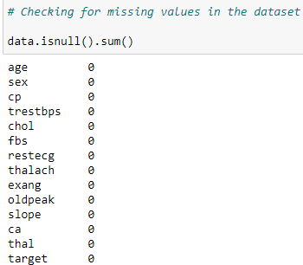

Identify and assess the extent of missing values in the dataset across all variables.Determine the appropriate strategy for handling missing values based on the nature and context of the data.Options for handling missing values include imputation (replacing missing values with estimated values), deletion (removing records or variables with missing values), or flagging (indicating missing values without removing them).

**Removing Duplicates:**

Identify and remove duplicate records or observations in the dataset.Use appropriate criteria for identifying duplicates, such as identical values across all variables or specific key variables.Remove duplicate records to prevent redundancy and ensure data integrity.

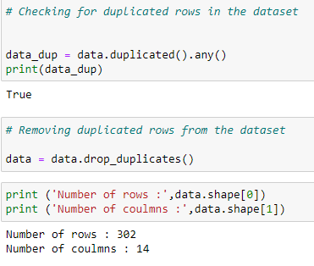

**Handling Outliers:**

Identify outliers, which are observations that deviate significantly from the rest of the data.

Use statistical methods, such as z-score analysis or interquartile range (IQR) method, to detect outliers in numerical variables.

Evaluate the impact of outliers on the analysis and determine the appropriate approach for handling them.

Options for handling outliers include trimming (removing extreme values), winsorization (replacing extreme values with less extreme values), or transformation (applying mathematical transformations to normalize the distribution).

**Data Transformation or Normalization:**

Assess the distribution and scale of numerical variables in the dataset.

Apply data transformation techniques, such as logarithmic transformation or Box-Cox transformation, to normalize skewed distributions and improve the symmetry of data.

Normalize numerical variables to a consistent scale using standardization or min-max scaling methods.

Ensure that categorical variables are appropriately encoded or transformed, such as converting categorical variables into dummy variables for analysis.

By following these detailed steps in the data cleaning process, the dataset can be prepared effectively for further analysis and modeling. This ensures that the data used for predictive analytics is accurate, reliable, and suitable for generating meaningful insights and predictions related to heart diseases.

**Exploratory Data Analysis (EDA):**

Exploratory Data Analysis (EDA) is a crucial step in understanding the underlying patterns and relationships within the dataset. The results of EDA provide valuable insights into the characteristics of the data and inform subsequent analysis and modeling decisions. The EDA process includes the following key components:

**Summary Statistics:**

Calculate descriptive statistics, such as mean, median, standard deviation, minimum, maximum, and quartiles, for numerical variables.

Summarize categorical variables by calculating frequency counts and percentages for each category.

**Distribution of Key Variables:**

Visualize the distribution of key variables through histograms, density plots, or box plots to understand their central tendency and variability.

Assess the skewness and kurtosis of numerical variables to identify potential deviations from normality.

**Correlation Analysis:**

Conduct correlation analysis to examine the strength and direction of relationships between pairs of variables.Calculate correlation coefficients, such as Pearson correlation coefficient or Spearman rank correlation coefficient, to quantify the degree of association between numerical variables.

Visualize correlation matrices using heatmaps to identify significant correlations and multicollinearity among variables.

**Visualization of Key Insights:**

Create visualizations, such as scatter plots, line plots, or bar charts, to explore relationships and patterns between variables. Use color coding and grouping to differentiate categories and highlight trends in the data.Generate interactive visualizations or dashboards to facilitate exploration and interpretation of key insights.

By presenting the results of exploratory data analysis, stakeholders gain a deeper understanding of the dataset's characteristics and relationships. This knowledge serves as the foundation for developing hypotheses, selecting appropriate modeling techniques, and generating actionable insights to address the objectives of the analysis.

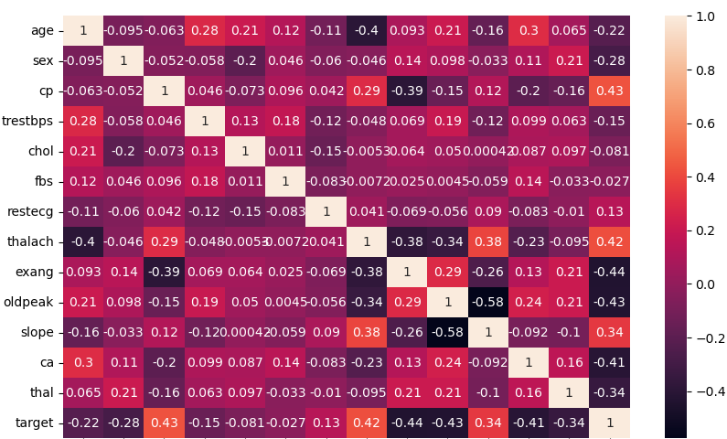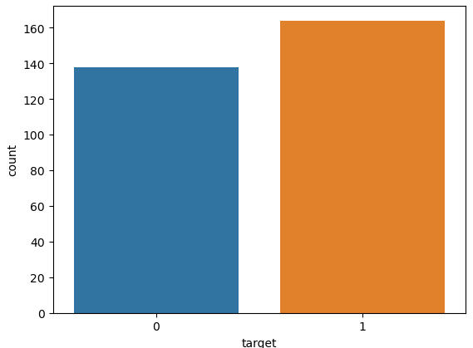

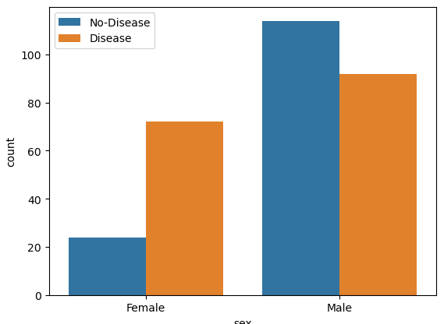 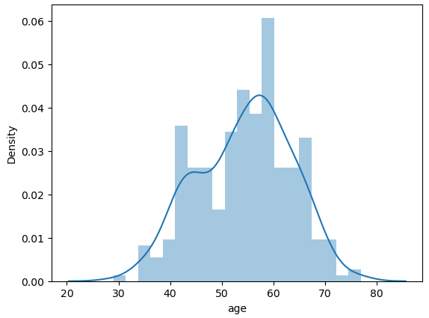

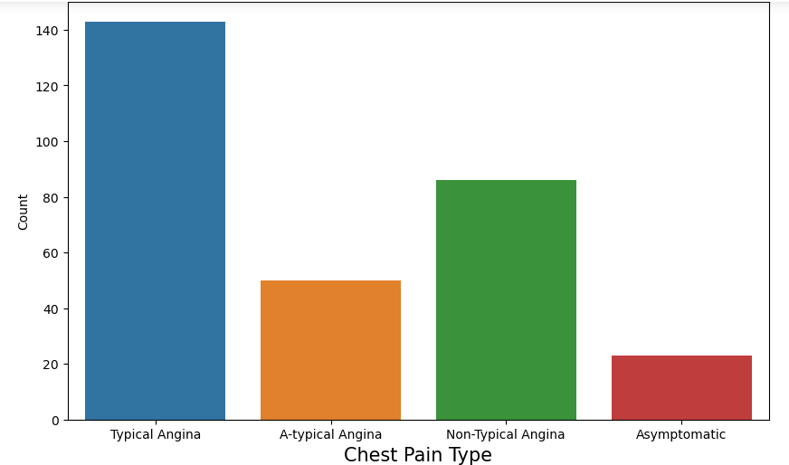 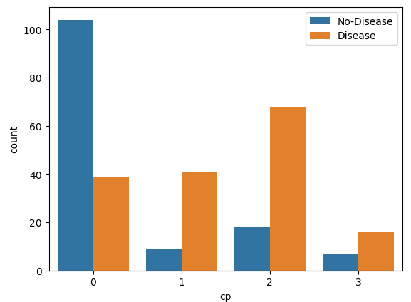 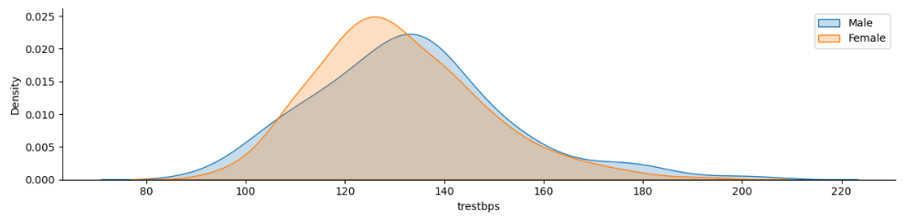

**Feature Engineering and Data Processing:**

Feature engineering and data processing are essential steps in preparing the dataset for modeling. These processes involve transforming raw data into a format suitable for predictive modeling and analysis. The key components of feature engineering and data processing include:

**Encoding Categorical Variables:**

Convert categorical variables into a numerical format that machine learning algorithms can process. Use techniques such as one-hot encoding or label encoding to represent categorical variables as binary or integer values. Ensure that the encoding method preserves the ordinal or hierarchical relationships among categories if applicable.

**Feature Scaling or Normalization:**

Scale numerical features to a consistent range to prevent variables with larger scales from dominating the model training process. Common scaling techniques include standardization (subtracting the mean and dividing by the standard deviation) or min-max scaling (scaling features to a specified range, such as [0, 1]).Normalize numerical features to improve the convergence and stability of optimization algorithms, particularly in models sensitive to feature magnitudes.

**Handling Multicollinearity:**

Identify and address multicollinearity, which occurs when independent variables are highly correlated with each other.Use correlation matrices or variance inflation factors (VIF) to detect multicollinearity among features.Address multicollinearity by removing redundant features, combining correlated features into composite variables, or applying dimensionality reduction techniques such as principal component analysis (PCA).\

**Feature Selection Techniques:**

Select a subset of relevant features that contribute most to the predictive performance of the model.Use feature selection methods such as filter methods (e.g., correlation-based feature selection), wrapper methods (e.g., recursive feature elimination), or embedded methods (e.g., regularization techniques) to identify the most informative features.

Consider domain knowledge, computational efficiency, and model interpretability when selecting features for the final model.By implementing feature engineering and data processing techniques, the dataset is transformed into a format optimized for predictive modeling. These steps enhance the predictive accuracy, interpretability, and generalization ability of machine learning models, leading to more robust and effective solutions for the analysis objectives.

**Model Selection:**

Model selection is a crucial step in predictive analysis, determining the most suitable machine learning models for the task at hand. This process involves careful consideration of various factors, including algorithms, evaluation criteria, and cross-validation techniques:

**Consideration of Various Algorithms:**

Evaluate a diverse range of machine learning algorithms, including regression, classification, and clustering algorithms, to find the best fit for the analysis. Consider the characteristics of the dataset, such as the type and distribution of features, the nature of the target variable, and the size of the dataset, when selecting algorithms. Choose algorithms that align with the objectives of the analysis and are capable of capturing the underlying patterns and relationships within the data.

**Evaluation Criteria:**

Define appropriate evaluation metrics to assess the performance of machine learning models objectively. Common evaluation metrics include accuracy, precision, recall, F1-score, and area under the receiver operating characteristic curve (AUC-ROC).Select evaluation criteria based on the specific goals of the analysis, emphasizing metrics that prioritize prediction accuracy, sensitivity to class imbalances, and overall model performance.

**Cross-Validation Techniques:**

Implement cross-validation techniques to estimate the generalization performance of machine learning models. Divide the dataset into training and testing sets using methods such as k-fold cross-validation or stratified cross-validation.

Use cross-validation to validate model performance across multiple subsets of the data, ensuring that the model's performance is consistent and reliable on unseen data.

**Reasons for Choosing These Models:**

**The selection of machine learning models is driven by several factors:**

**Accuracy**: The chosen models have demonstrated high accuracy in predictive tasks, ensuring reliable predictions for heart disease diagnosis.

**Interpretability**: Models such as logistic regression provide transparent interpretations of feature importance, aiding in understanding the factors contributing to heart disease.

**Robustness**: Algorithms like random forest and gradient boosting are robust to noisy data and outliers, improving model stability and reliability.

**Flexibility**: Consideration of various algorithms allows for flexibility in addressing different aspects of the prediction task, ensuring comprehensive coverage of potential patterns in the data.

**Cross-validation**: By incorporating cross-validation techniques, the selected models are rigorously evaluated for generalization performance, enhancing their reliability and trustworthiness in real-world applications.

In summary, the chosen models offer a balance of accuracy, interpretability, robustness, and flexibility, supported by thorough cross-validation techniques, making them well-suited for the predictive analysis of heart diseases.

**Explanation of the Models Used:**

In the analysis, several machine learning models were employed to predict heart diseases. Each model offers unique characteristics and advantages, contributing to the overall effectiveness of the analysis:

**Logistic Regression:**

Description: Logistic regression is a linear regression model used for binary classification tasks.

Application: It estimates the probability of a binary outcome based on one or more predictor variables.

Advantages: Logistic regression provides interpretable results, allowing us to understand the impact of each feature on the likelihood of heart disease.

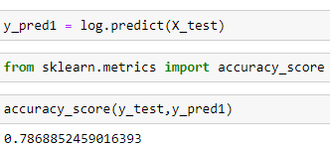

**Support Vector Machine (SVM):**

Description: SVM is a powerful supervised learning algorithm used for both classification and regression tasks.

Application: It identifies the optimal hyperplane that separates classes in high-dimensional feature space, maximizing the margin between classes.

Advantages: SVM is effective in handling complex, nonlinear relationships in the data, making it suitable for heart disease prediction with potentially nonlinear decision boundaries.

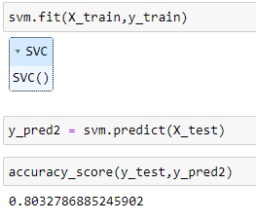

**K-Nearest Neighbors (KNN):**

Description: KNN is a simple, instance-based learning algorithm used for classification and regression tasks.

Application: It predicts the class of a new observation by considering the majority class among its k nearest neighbors in the feature space.

Advantages: KNN is intuitive and easy to implement, making it a useful baseline model for heart disease prediction.

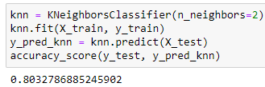

**Decision Tree Classifier:**

Description: Decision tree is a tree-like structure used for classification and regression tasks.

Application: It recursively partitions the feature space into subsets based on feature values, making binary decisions at each node.

Advantages: Decision trees are interpretable and can capture complex, nonlinear relationships between features, making them suitable for heart disease prediction with potentially intricate decision boundaries.

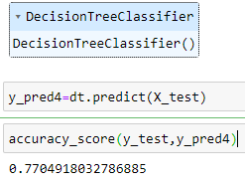

**Random Forest Classifier:**

Description: Random forest is an ensemble learning technique that combines multiple decision trees to improve prediction accuracy and reduce overfitting.

Application: It aggregates predictions from a collection of decision trees, each trained on a random subset of the data and features.

Advantages: Random forest offers high prediction accuracy, robustness to noisy data, and resilience to overfitting, making it a powerful model for heart disease prediction.

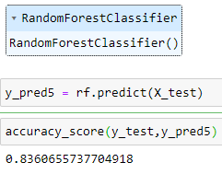

**Gradient Boosting Classifier:**

Description: Gradient boosting is an ensemble learning technique that builds a strong predictive model by combining multiple weak learners sequentially.

Application: It iteratively fits new models to the residuals of the previous models, optimizing a predefined loss function.

Advantages: Gradient boosting achieves state-of-the-art performance in predictive tasks, effectively capturing complex relationships and interactions among features in the data.

By leveraging a diverse set of machine learning models, the analysis explores different approaches to heart disease prediction, ensuring comprehensive coverage of potential patterns and relationships within the data. Each model contributes unique strengths and capabilities, ultimately enhancing the accuracy and reliability of the predictive analysis.

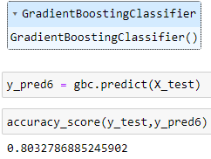

**Reasons for Selecting RandomForest Classifier:**

**High Prediction Accuracy:** The Random Forest Classifier is chosen due to its proven track record of delivering high prediction accuracy in various machine learning tasks. It excels in capturing complex relationships within the data, making it particularly suitable for heart disease prediction, where subtle interactions between risk factors may influence disease occurrence.

**Robustness to Noise:** Random Forests are robust to noisy data and outliers, which are common challenges in healthcare datasets. By aggregating predictions from multiple decision trees trained on different subsets of the data, the model mitigates the impact of outliers and noisy features, resulting in more reliable predictions.

**Ability to Handle Large Feature Sets:** In heart disease prediction, numerous features may contribute to the risk assessment. Random Forest Classifier's ability to handle large feature sets makes it well-suited for analyzing datasets with a wide range of potential risk factors, ensuring comprehensive coverage and accurate prediction.

**Reduced Risk of Overfitting:** Overfitting, where a model learns to memorize the training data rather than capturing underlying patterns, is a common concern in machine learning. Random Forests mitigate overfitting by aggregating predictions from multiple trees, each trained on a random subset of the data. This ensemble approach reduces the risk of overfitting and enhances the model's generalization performance on unseen data.

**Interpretability and Feature Importance:** While Random Forests are inherently complex models, they provide insights into feature importance, allowing stakeholders to understand the relative contributions of different risk factors to heart disease prediction. This interpretability enhances the model's transparency and facilitates decision-making in clinical settings.

Overall, the Random Forest Classifier is selected for its superior prediction accuracy, robustness to noise, ability to handle large feature sets, reduced risk of overfitting, and provision of interpretability, making it a compelling choice for heart disease prediction tasks**.**

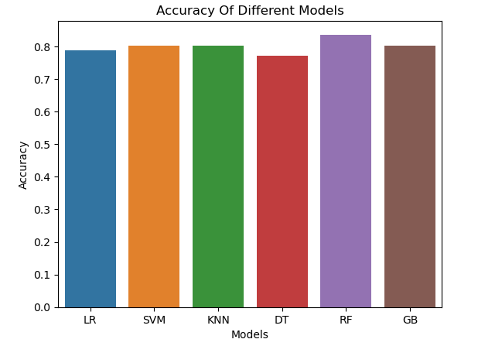

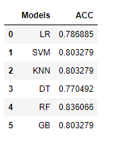

**Power BI Dashboard Overview:**

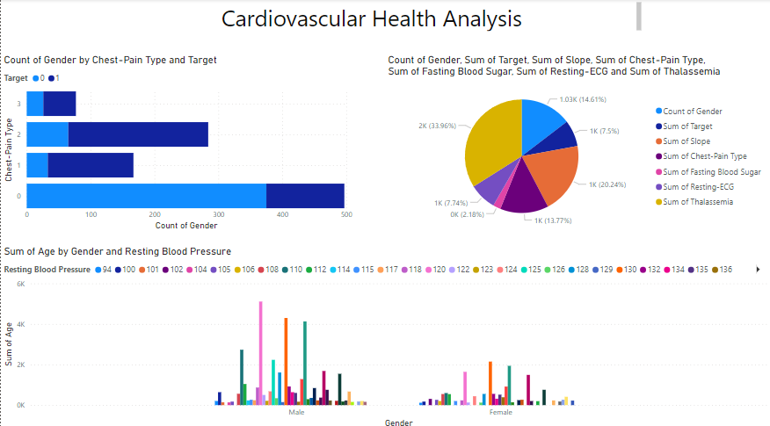

**Stacked Bar Chart:**

Description: The stacked bar chart visually represents the distribution of chest pain types among different genders, segmented by the presence or absence of heart disease (target).

Y-axis: Represents the types of chest pain (e.g., typical angina, atypical angina, non-anginal pain, asymptomatic).

X-axis: Indicates the count of individuals of each gender (male/female).

Legend: Displays two categories representing the presence or absence of heart disease (target), enabling comparison between individuals with and without heart disease for each chest pain type.

**Pie Chart:**

Description: The pie chart provides a holistic view of various demographic and clinical factors aggregated across the dataset.

Values: Each segment of the pie chart represents the aggregated sum or count of specific variables:

Count of Gender: Distribution of males and females in the dataset.

Sum of Target: Total number of individuals diagnosed with heart disease.

Sum of Slope: Aggregate value of the slope of the peak exercise ST segment.

Sum of Chest-Pain Type: Total occurrences of different types of chest pain.

Sum of Fasting Blood Sugar: Total count of individuals with elevated fasting blood sugar levels.

Sum of Resting-ECG: Aggregate sum of resting electrocardiographic results.

Sum of Thalassemia: Total count of individuals with different types of thalassemia.

**Clustered Column Chart:**

Description: The clustered column chart presents the distribution of age and resting blood pressure across genders.

X-axis: Represents the two genders, male and female.

Y-axis: Displays the aggregated sum of age and resting blood pressure for each gender.

Legend: Indicates the resting blood pressure, allowing comparison between genders regarding their average age and resting blood pressure.

These visualizations offer a comprehensive overview of demographic characteristics, clinical variables, and their relationships within the dataset, facilitating insights into heart disease risk factors and demographics associated with specific clinical outcomes.